Haresh Bharadwaj – 192321037

**26) Design wireframes for a mobile app showcasing data replication techniques. Use Figma to demonstrate the synchronization process.**

**Aim:**

ToDesign a mobile app showcasing data replication techniques using figma

**Procedure:**

1. Open Figma
2. Create a new file
3. Select the Frames
4. Design Visual Elements
5. Make it Interactive
6. Add icons on the Frame
7. Incorporate Multimedia
8. Storyboard Animation
9. Review and edit the Prototype
10. Save and Share

Design:

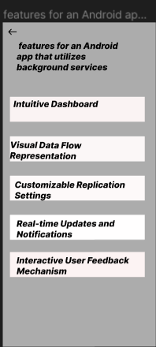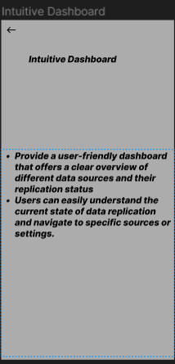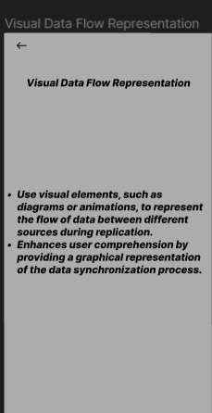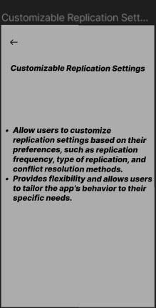

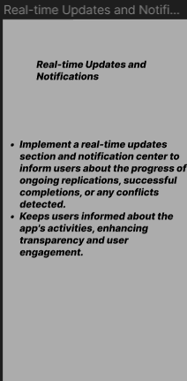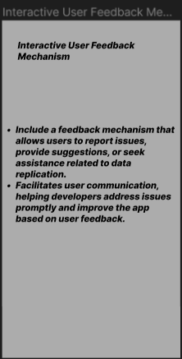

Prototype:

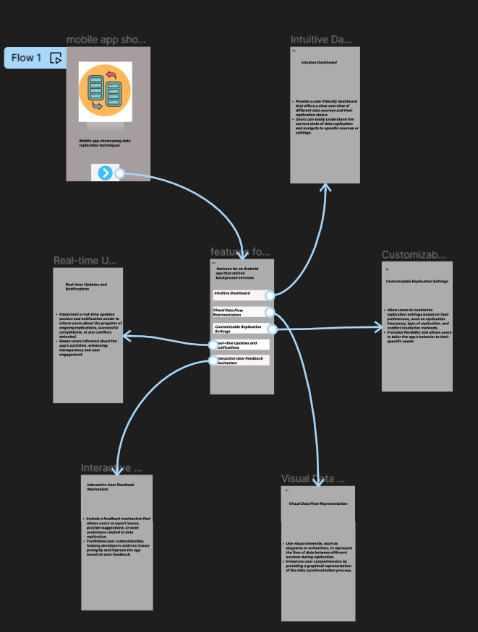

**Result:** Hencea mobile app showcasing data replication techniques using figma have been created successfully